Congratulations! You have purchased a Kersplash Challenger Pool Climbing Wall from Spectrum Aquatics. Providing the unit is installed correctly and properly maintained, it will furnish you with many years of trouble-free use. It is important to read this entire manual prior to beginning assembly or operation.
Shipping Information:
Each wall module will arrive packaged from Spectrum. Before accepting the unit from the carrier, inspect for visible damage and match the contents with those listed below. Spectrum Aquatics is not responsible for lost or damaged freight.
The packaging will contain all structural components, hardware, and panels. The following is a list of the components included with your shipment from Spectrum Aquatics.
16’ 4 Panel Climbing Wall: Part Number 2210777
1 | 304L Stainless Steel Long Base | 1 | 304L Stainless Steel Lower Frame
1 | 304L Stainless Steel Mid Frame | 1 | 304L Stainless Steel Top Frame
2 | 304L Stainless Steel Tall Brace A | 2 | 304L Stainless Steel Tall Brace B
2 | 304L Stainless Steel Tall Brace Support Assembly | 4 | 4’ x 4’ Climbing Panels
1 | 2’ x 4’ Safety Panel | 1 | Hardware Package
6 | Anchoring Brackets | 3 | Kersplash Climbing Wall Rules Signs
24 | Hand Holds
12’ 3 Panel Climbing Wall: Part Number 2210888
1 | 304L Stainless Steel Short Base | 1 | 304L Stainless Steel Lower Frame
1 | 304L Stainless Steel Med Upper Frame | 2 | 304L Stainless Steel Med Brace A
2 | 304L Stainless Steel Med Brace B | 2 | 304L Stainless Steel Med Brace Support Assembly
3 | 4’ x 4’ Climbing Panels | 1 | 2’ x 4’ Safety Panel
1 | Hardware Package | 4 | Anchoring Brackets
3 | Kersplash Climbing Wall Rules Signs | 18 | Hand Holds
8’ 2 Panel Climbing Wall: Part Number 2210999
1 | 304L Stainless Steel Short Base | 1 | 304L Stainless Steel Lower Frame
1 | 304L Stainless Steel Top Frame | 2 | 304L Stainless Steel Short Brace
2 | 4’ x 4’ Climbing Panels | 1 | 2’ x 4’ Safety Panel
1 | Hardware Package | 4 | Anchoring Brackets
3 | Kersplash Climbing Wall Rules Signs | 12 | Hand Holds

Installation Overview
Please make sure to read all instructions before attempting to assemble or install the wall. Due to the wide variety of pool deck configurations, it is recommended that you contact Spectrum Aquatics for a drawing packet that will configure the mounting holes, spacers, and setback for your deck application.
Tools & Equipment Required:
- Hammer Drill
- 5/8” Hammer Drill Bit
- Compressed Air
- Steel Brush
- 7/32” Allen Wrench (included)
- 7/16” Wrench or Socket
- 9/16” Wrench or Socket
- 5/8” Wrench or Socket
- 3/4” Wrench or Socket
Soft Faced Hammer

CLEAR DECK SPACE
To be compliant with most state and local guidelines there must be at least 4’ of clear deck space from the back of the frame on the deck to any obstruction. Please verify your local and state codes prior to installation.
POOL DEPTH
Pool depth requirements vary by state. Check your state and local codes to ensure your configuration complies. Spectrum Aquatics recommends the following depths for its different panel configurations:
WALL HEIGHT | RECOMMENDED WATER DEPTH
8 FEET | 5 ft
12 FEET | 6 ft
16 FEET | 9 ft
CLIMBING WALL ASSEMBLY
Assembly will take place in eight steps.
1) Attach holds to panels
2) Attach panels to frame
3) Anchor base to deck using epoxy anchors and anchor brackets
4) Attach lower frame to base
5) Attach mid and or upper frames to lower frame
6) Attach braces to frame
7) Pivot frame upright, attach braces to base
8) Tighten all remaining fasteners
Installation Instructions
Prior to assembly, be sure to gather all your tools and prepare all materials. If a Crystal Clear wall is chosen, the protective wrapping will need to be removed from the panels prior to assembly, and care taken not to scratch the panels during the installation process.
ATTACHING THE HAND HOLDS
1. Place the Hand Hold over the desired set of holes in the wall panel.
2. Insert 2” button head bolt, and 3/8” washer through the Hand Hold and through the 1/2” clear panel. Attach the 3/8” rubber seal washer over the bolt threads and thread on the 3/8” lock nut.
3. Using an Allen Wrench (included) and a 9/16” box wrench or socket wrench, hand tighten.
4. Repeat steps 2 and 3 for the second bolt.
5. Fill holes in unused positions with plugs.
a. Allen Wrench
b. 2” Button Head Bolt
c. 3/8” Flat Washer
d. Hand Hold
e. Panel
f. Seal Washer
g. 3/8” Nylock Nut
h. Plugs

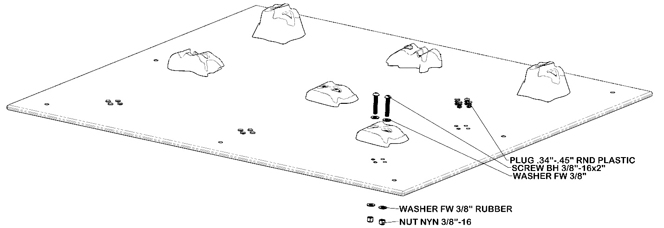

ATTACHING THE CLIMBING PANELS TO THE FRAME
Place the panels on top of the frame and drop in button head screws to hold the panels in place, but do not tighten. Panels should be flush with the upper and lower edges of the frame section they attach to. This will prevent gaps in the overall assembly. After you’re satisfied with the fit, tighten fasteners. Attach the link plate between the two panels attached to the lower frame through the center position. The upper safety panel should be positioned so its lower edge touches the climbing panel below it when in proper position.
Attach each climbing panel to the climbing frame as shown below using the following hardware:
6 - 3/8” x 2 3/4” Button Head Socket Screw
Or
2 - 3/8” x 1 1/4” Button Head Socket Screw
16 - 3/8” Flat Washers
8 - 3/8” Nylock Nuts
1-Link Plate

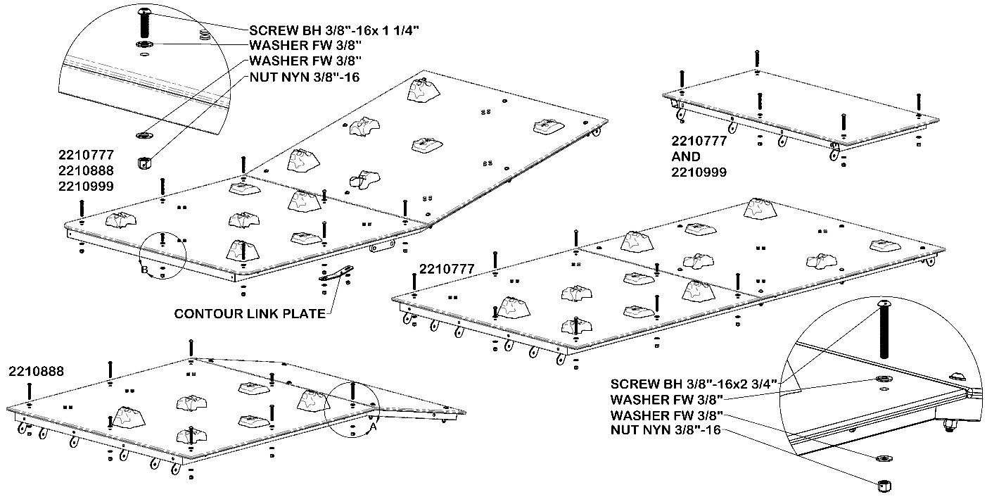
Affix the 2’ x 4’ safety panel to the top of the climbing frame using:
4 - 3/8” x 2 3/4” Button Head Socket Screws
Or
1 – 3/8” x 1 1/4” Button Head Socket Screw
10 - 3/8” Flat Washers
5 - 3/8” Nylock Nuts

POSITIONING, ANCHORING, AND CONNECTING THE BASES:
• The base of the climbing wall should be set so that there is no less than 1” and no more than 4” of clearance between the climbing wall and the existing pool wall (verify local and state codes). Please note that the lower section mounting brackets on the base are 1/8” closer to the pool wall than the final position of the lower section.
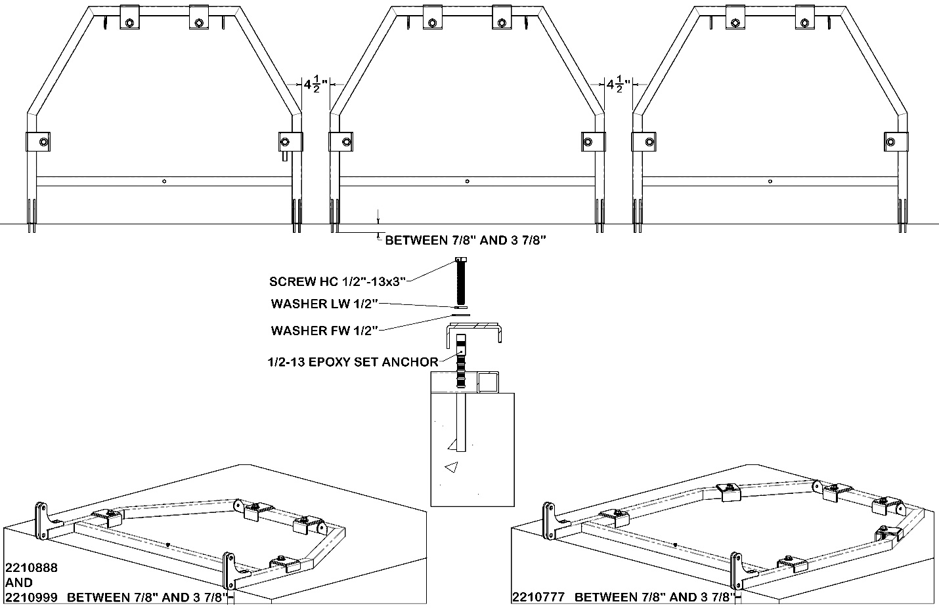
• If you are assembling several units into a continuous wall, bases must be spaced 4 1/2” from each other.
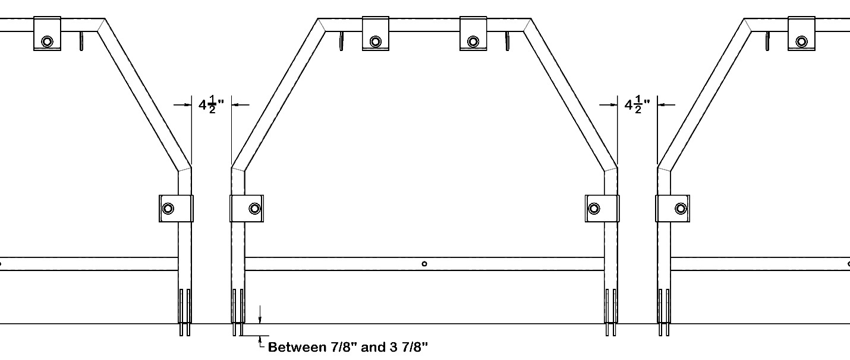
ANCHORING THE CLIMBING WALL:
Anchoring should be done by an installer experienced with the use of 1/2” drop in epoxy anchor.
STEP 1) Prior to drilling and anchor installation, read, and follow instructions below, and wear approved eye and ear protection.
STEP 2) There is a requirement of 6 anchoring brackets for the 16’ wall, 4 brackets for the 12’ wall and 4 brackets for the 8’ wall.
STEP 3) Mark or partially drill the holes. Move the anchor brackets and finish drilling the holes as discussed in instructions below.

To set anchor flush with surface:
1. Drill hole a 5/8” hole to 4 1/8" deep.
2. Clean hole with pressurized air and nylon brush.

3.Fill hole ~1/3 full with an appropriate anchoring epoxy. Redhead G5 or Hilti 200 are both commonly available epoxies.
4. Insert anchor into the hole with a slow twisting motion and allow epoxy to cure for the recommended time.
BONDING THE CLIMBING WALL:
Check state and local code for bonding requirements. Spectrum has provided a grounding screw in the base crossbar for bonding purposes.

ATTACHING THE LOWER FRAME
1. Place lower frame mounting brackets in base brackets. Align holes and insert ½” hardware. Depending on your installation, it may be helpful to insert upper bolts only while the lower frame is parallel with the deck and then pivot the lower frame into its permanent position perpendicular to the deck before inserting the lower bolts.
Use 1/2” x 2” Hex head bolts, 1/2” flat washers, and 1/2” nylock nuts for this assembly step.

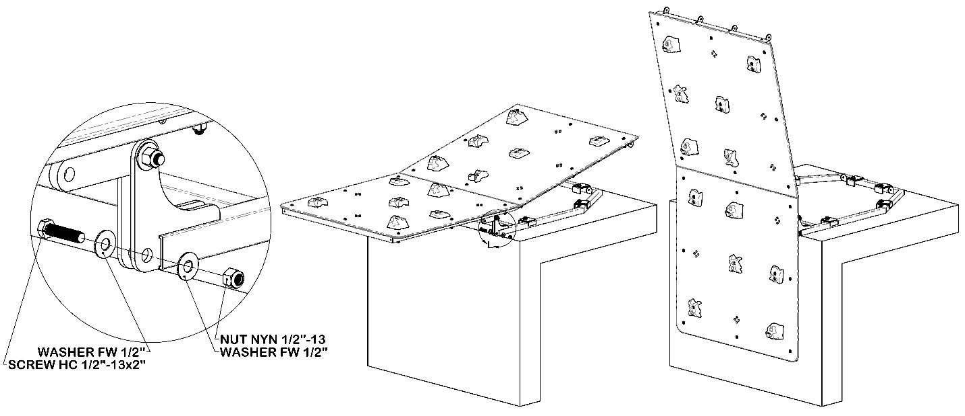

ATTACHING THE MIDDLE AND UPPER FRAME
1. The details of this step will vary depending on your wall model, but the basic process is similar. For 2210777, the 4 panel wall, you will be attaching the Mid Frame and Top Frame at this time. For 2210888, the 3 panel wall, you will be attaching the Upper Frame. 2210999, the 2 panel wall, needs only the Top Frame. Align the hinge tabs between the lower frame and the section you are attaching. Do this with the new parts in a leaned back orientation. Assembling while upright would be challenging. Insert 3/8” hardware in the hinge tabs but do not fully tighten yet. On 2210777, the Top Frame should be attached to the Mid Frame at this time. Use hardware including 4 ½” long screws to secure the Top Frame in its final position on 2210777 and 2210999. Tighten Top Frame hardware.
Use 3/8” x 1” button head bolts, 3/8”x 4 1/2 button head bolts, 3/8” flat washers, and 3/8” nylock nuts for this assembly step.

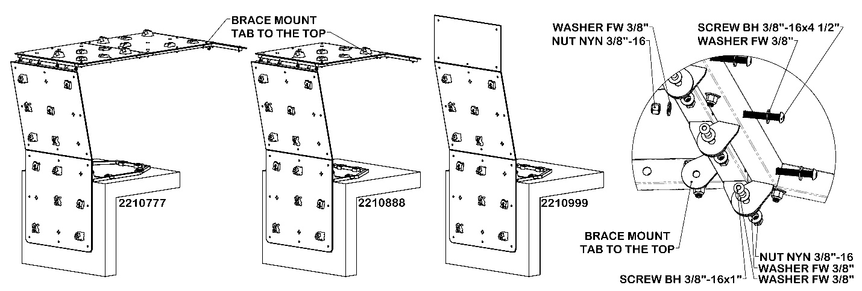

ATTACHING THE BACKS BRACES TO FRAME
1. The details of this step will vary depending on your wall model, but the basic process is similar. For 2210777, the 4 panel wall, and 2210888, the 3 panel wall, you will assemble the back braces and then mount them. 2210999, the 2 panel wall, you can simply mount the braces using 3/8” hardware. On 221077 and 2210888, locate Brace A, Brace B, Brace C, and Brace Connector Bracket. Assemble two Brace assemblies as mirrors of each other using 3/8” hardware.. Please note the direction of the angled cut on the end of the Brace bars. It should match per side. Attach Brace Assembly to the tabs near the top of the wall leaving Braces stretched back from the unit across the pool deck.
Use 3/8” x 1” button head bolts, 3/8” x 2 ¼” button heads, 3/8”x 2 ½” button head bolts, 3/8” flat washers, 3/8” Achorn nuts and 3/8” nylock nuts for this assembly step.
Please note that on 2210777, the longer of the back brace bars go toward the top of the unit.
Please note that on 2210888, the shorter back brace bars go toward the top of the unit.
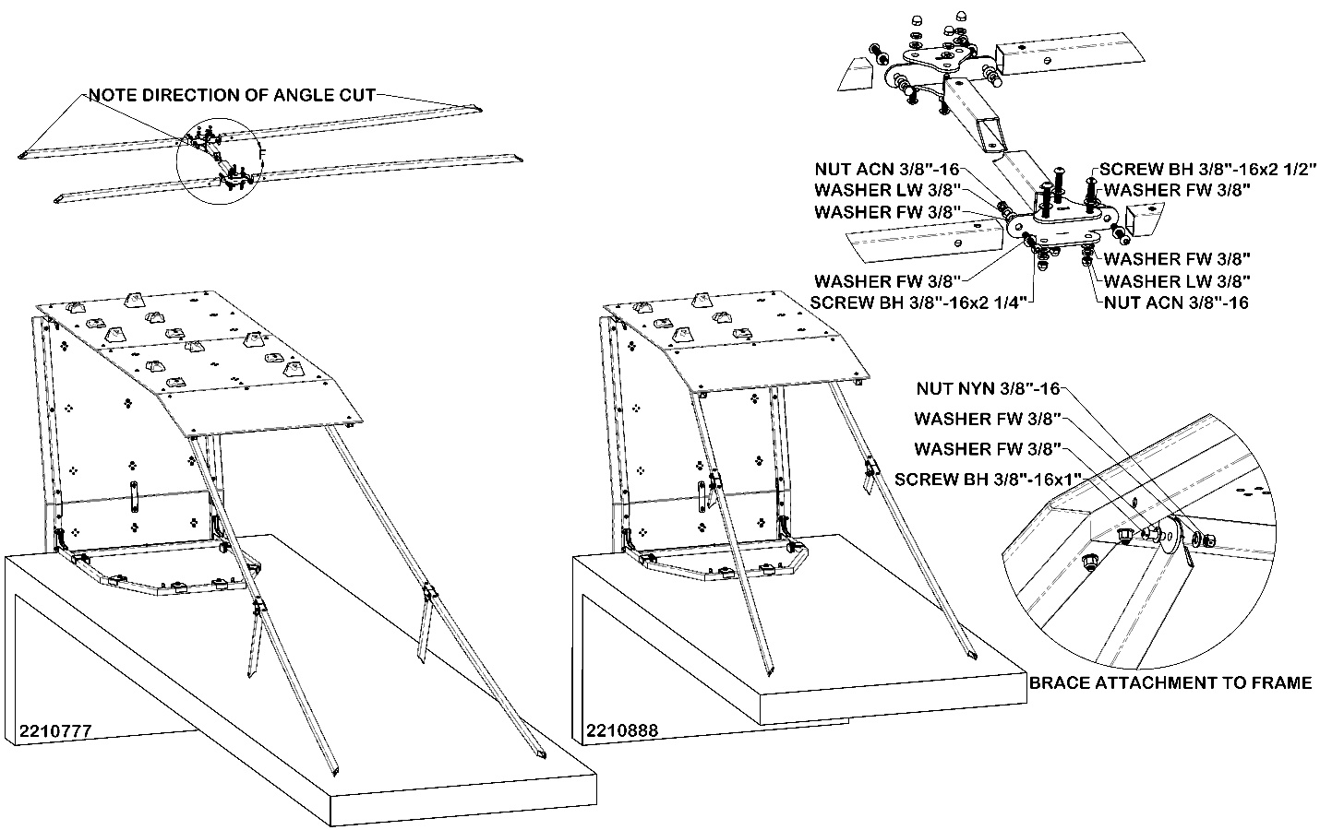

PIVOT FRAME UPRIGHT
2210777, the 4 panel wall, and 2210888, the 3 panel wall, only. Using the Brace Assemblies as push bars, pivot the upper wall sections into their upright position. Once it is in position, use 3/8” hardware to attach the Brace Assemblies to the wall lower and middle attachment tabs. Use 3 ½” bolts to secure the joint between the Lower Frame and the upper assembly.
Use 3/8” x 1” button head bolts, 3 ½” button head bolts, 3/8” flat washers, 3/8” and 3/8” nylock nuts for this assembly step.
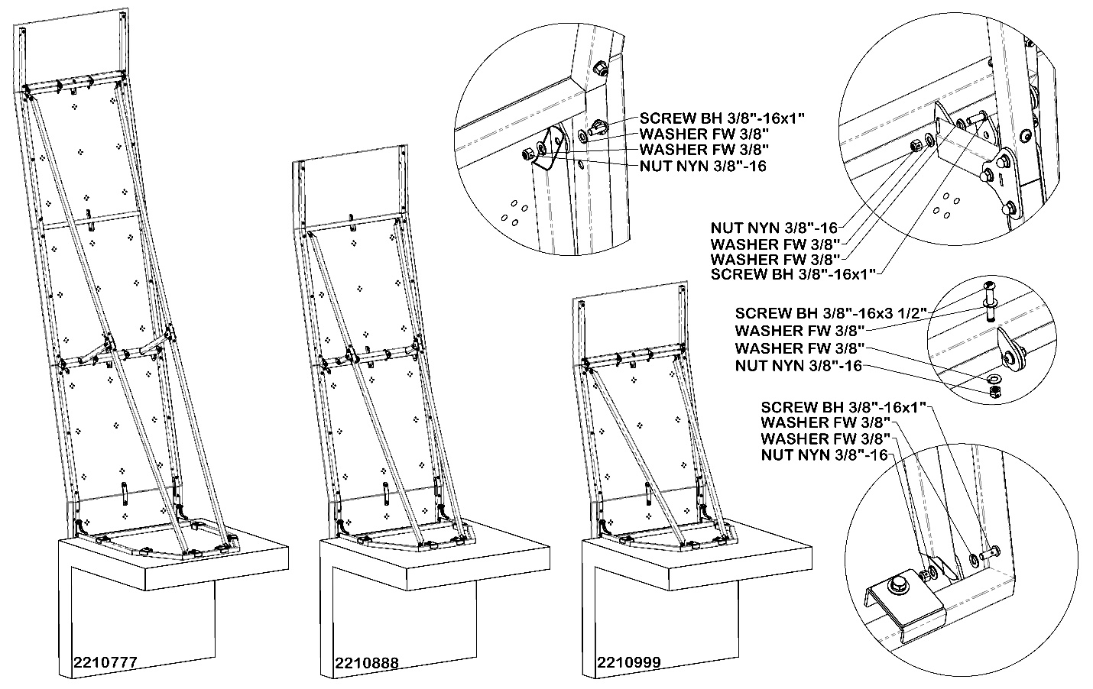

TIGHTEN FASTENERS
2210777, 2210888, 2210999 Tighten all hardware.

ADDITIONAL INSTRUCTIONS:
WARNING! Read all operating instructions before using the Kersplash Pool Climbing Wall. Make sure that all individuals using the wall have read and understand the Kersplash Climbing Wall Rules. Supervision is required.
WARNING! Rock climbing indoors and outdoors is an inherently dangerous sport. The activity of climbing can lead to significant personal injury, disfigurement, or death. Even though one may be climbing indoors on an artificial wall, risks still exist. Artificial holds can spin, and on rare occasions break. Individual climbers and organizations have the sole responsibility for learning and using proper climbing techniques and safety practices. The purchasers and users of our products accept full and complete responsibility for any and all damages or injury which may result from the use and/or misuse of any product purchased from Spectrum Aquatics.
WARNING! This product may contain chemicals known to the State of California to cause cancer and birth defects or other reproductive harm.9

OPERATOR’S GUIDE
Safety Precautions:
• Spectrum Aquatics recommends that a lifeguard be on duty at all times when the Kersplash Pool Climbing Wall is in use. This may be required by certain states; check your state and local codes to verify.
• NO DIVING is allowed off the Kersplash Pool Climbing Wall.
• Kersplash Pool Climbing Wall users must be able to swim; we recommend use for ages 5 and above.
KERSPLASH CLIMBING WALL RULES
• Swimmers only may use the Kersplash Climbing Wall; non-swimmers and beginners should not use the wall.
• Swimming ability should be determined by a 25-yard swim and a 30 second treading exercise.
• Climbers must read, understand, and obey all posted rules, instructions, and warnings.
• Only one climber is allowed on the Climbing Wall at a time.
• Only feet-first entries are allowed when entering the water. NO EXCEPTIONS!
• No climbing on the back or sides of the structure. Climb only on the hand holds.
• Climbers who intentionally violate the NO DIVING rule WILL BE BANNED from using the Kersplash Climbing Wall.
• When entering the water, knees should be bent, and arms extended for safety through increased deceleration.
• The entrance and exit paths dictated by the aquatic facility must be followed.
• When the Climbing Wall is open for use, a lifeguard must supervise the use of the structure without performing any other duties or observations.
• Climbers may not use the wall without the direct supervision of a lifeguard in close proximity of the structure.
• Climbers must listen to and obey the lifeguards monitoring the structure.
• Climb must begin from the water.
• Diving may result in bodily injury or death.
• Swim away from the climbing wall drop zone when you are done with your climb.
• Report any damaged equipment to the supervisor.
Care and Maintenance
Daily Maintenance:
• Spray frame, panels and hand holds with cold, clean, non-chlorinated water.
The proper care and maintenance of your climbing wall is essential and is your responsibility. Inspect your climbing wall and its components on a regular basis. These inspections should include, but are not limited to, the following:
Surface
• Panels should be installed according to installation instructions.
• Check panels to make sure they are in good condition and show no signs of stress.
• Check each panel’s adherence to the frame. Tighten only when they are loose. Do not over tighten!
• Check for sharp points and edges.
• Remove or repair any damaged wall areas.
• Clean panels with mild soaps or Windex cleaner. Regularly spraying down panels with non-chlorinated cold water to remove chlorine water spotting is recommended.
Hand Holds
• Hand Holds should be mounted according to the installation instructions.
• Observe holds for signs of stress or breakage.
• Remove and replace any damaged holds.
• Check hand holds for looseness and tighten. Do not over tighten!
• Wash holds periodically to remove oil, stains, and other residue. Remove hand holds and use mild soap and water with a soft bristle brush. Do not use a wire or brass bristle brush. You can also wash holds in a dishwasher. Towel dry holds and then air dry for 24 hours to ensure complete drying.
Frame
• Frame should be installed according to installation instructions.
• To clean, use only cold, clean, non-chlorinated water. Do not spray with high-pressure water.
• Remove any discoloration to the stainless steel frame with a 3M scratch pad. Wipe clean with a sponge dampened with Spectra Clean. Repeat these steps several times to passivate the stainless steel. Spectra Clean kits are available from Spectrum Aquatics (Part Number 202050-00), call 800.791.8056.11

