STEP INSTALLATION INSTRUCTIONS

Tools needed for assembly:
- 3/16” Hex Wrench
- Crescent or ½” Open End wrench

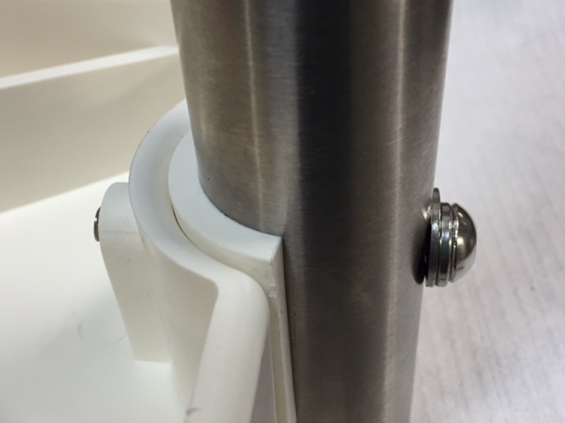
1.5”RAIL
WITH SPACER
- SPACER:
The spacer is ONLY USED ON 1.5” RAIL. Please
discard it if your product is 1.9” diameter rail.
- ASSEMBLY:
  - Remove the bolt, washers, spacer, and
nut from each side of the step.
  - Place the step between the rails.
  - Install the bolt from the outside with the FLAT
washer against the rail
  - HAND TIGHTEN with the Hex Wrench, being
very careful to not over tighten.
  - Place a flat washer on the end of the bolt and
then the Nylock nut. Tighten.

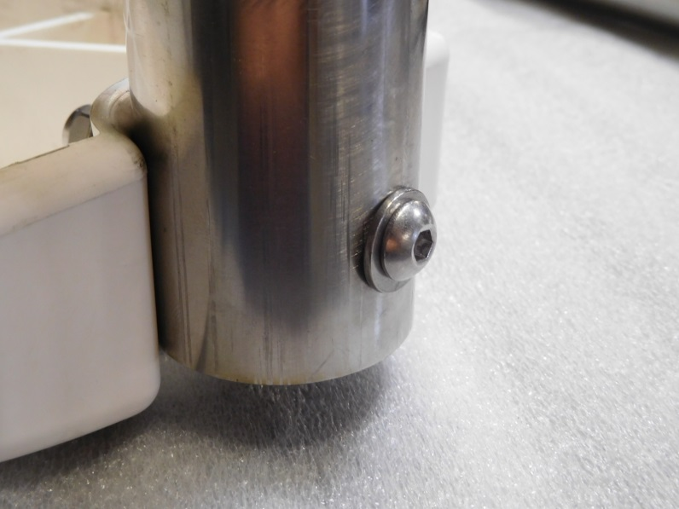
1.9”RAIL –
NO SPACER
FLAT WASHER
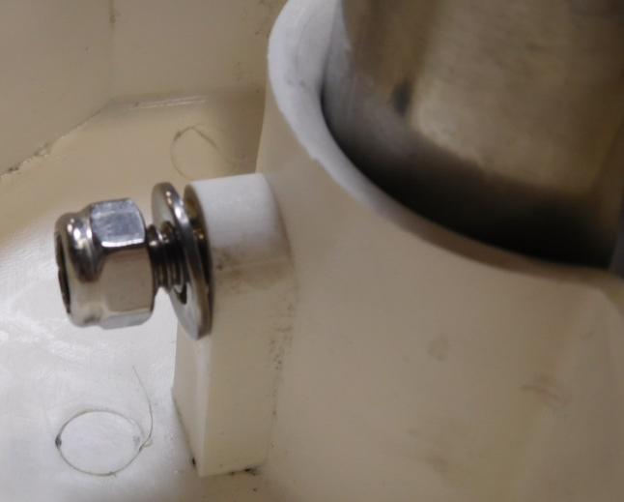

FLAT WASHER
AND
NYLOCK NUT

Contact Spectrum Customer Service if you require assistance:800-791-8056 or parts@spectrumproducts.com

