POOL SLIDE
  - BY SPECTRUM AQUATICS

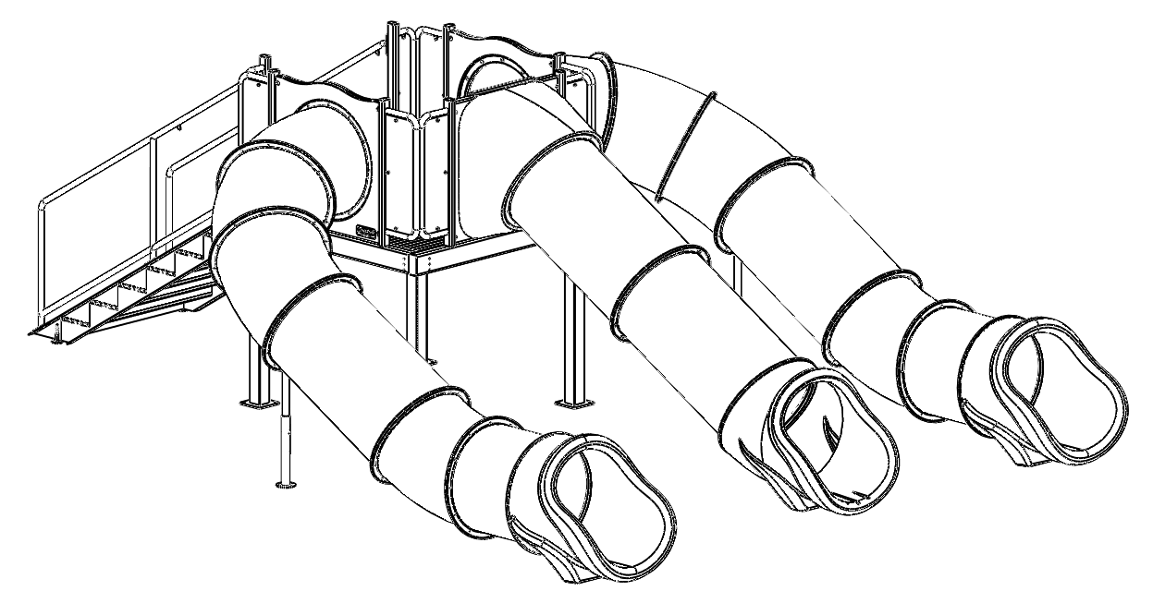
*Available in single double and triple flume models
*Available in 8’8” and 4’8” deck elevations

7100 Spectrum Lane | Missoula MT 59808 | 800.791.8056 | www.spectrumproducts.com
© 2013 EverActive Brands™

You have purchased a Spectrum Aquatics® Pool Slide. Providing the unit is installed correctly and properly maintained, it will furnish you with many years of trouble-free use. It is important to read this entire manual prior to beginning assembly or operation.

Shipping Information:
Each slide will arrive partially assembled on several pallets. Before accepting from the carrier, inspect for visible damage and match the contents with those listed below. Spectrum is not responsible for lost or damaged freight.
The pallets will contain all structural components and hardware. The following is a list of the components included with your shipment from Spectrum. Use Components and Hardware Figure, Page 2, as a reference to identify each item listed. The flumes will be shipped to your location separately and may be packaged on several pallets.
1 | HARDWARE BOX | 1 | STAIRCASE FRAME END
1 | FLUME FRAME END | 2 | FLUME FRAME SIDES
1 | STAIRCASE | 2 | HANDRAILS
2 | DECKING PANELS | 2 | FLUME SUPPORT STANDS
1 | WATER SPRAYER KIT | 1 | CENTER SUPPORT

Components
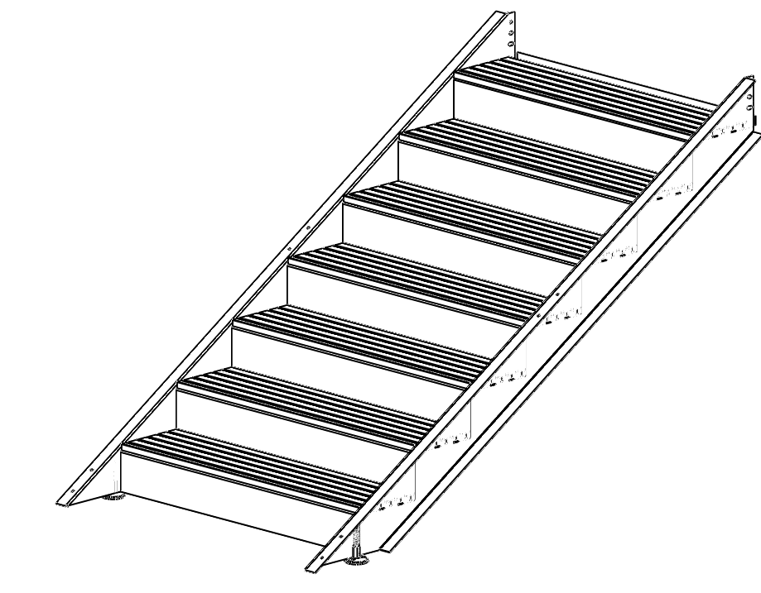 | 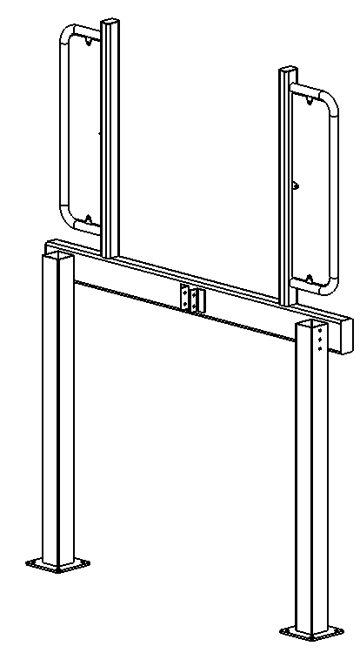 | 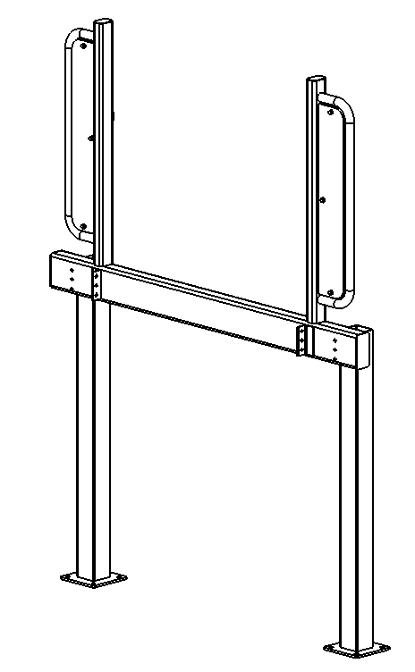
STAIRCASE | FLUME FRAME END | STAIRCASE FRAME END
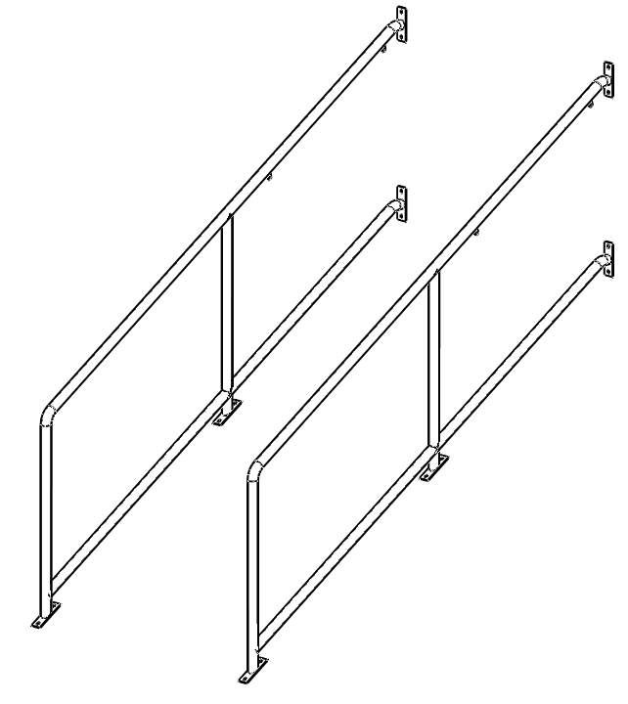 | 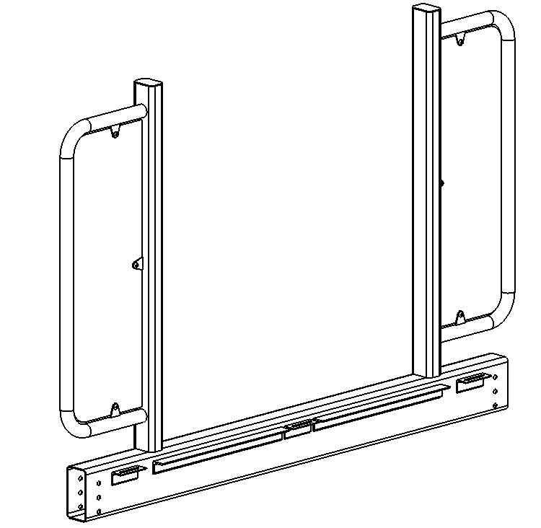 | 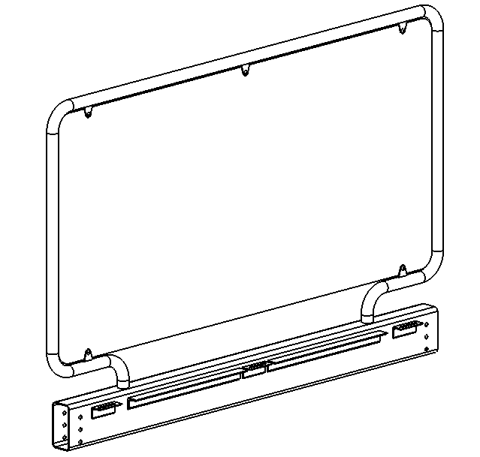
HANDRAILS | FLUME FRAME SIDE | FRAME SIDE
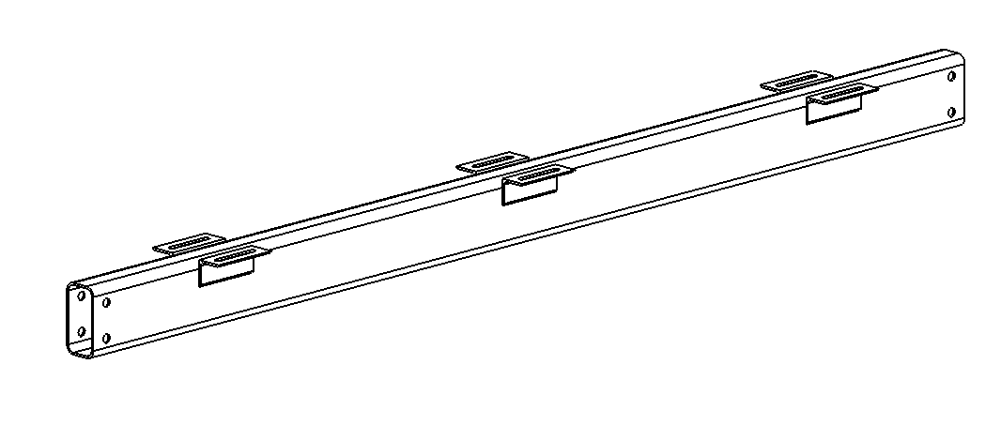 | 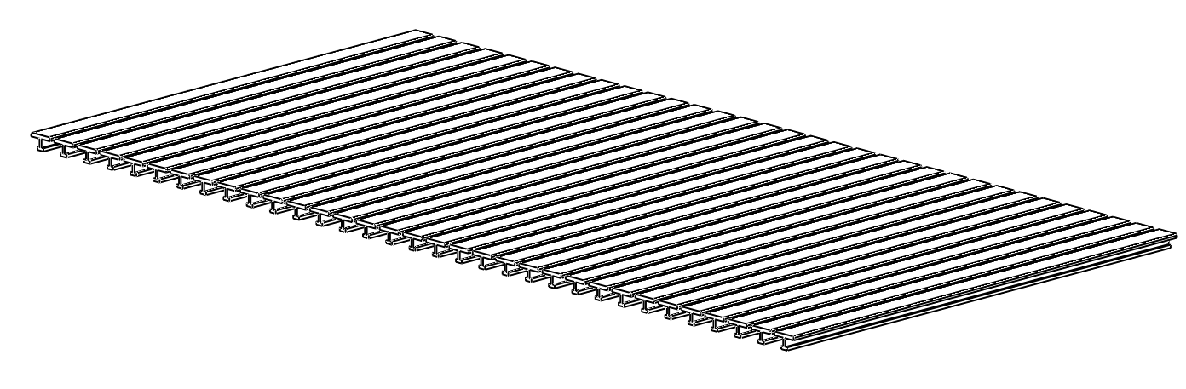 | 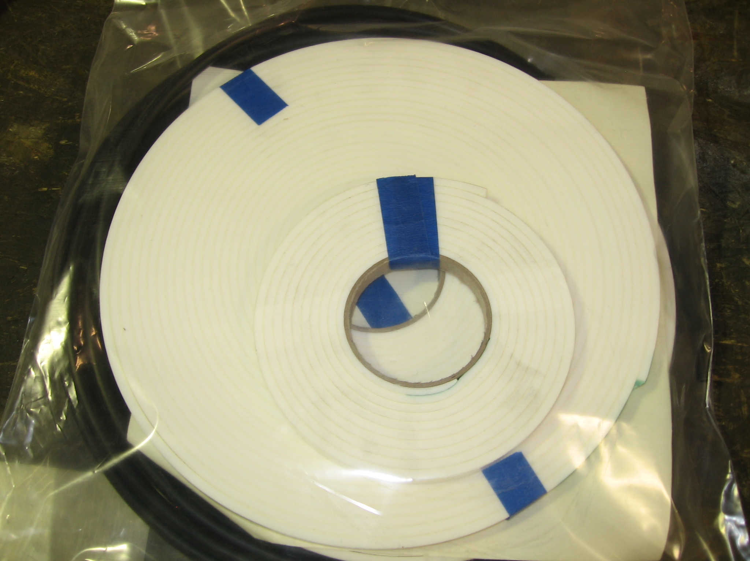
CENTER SUPPORT | DECKING PANEL | PLUMBING KITS
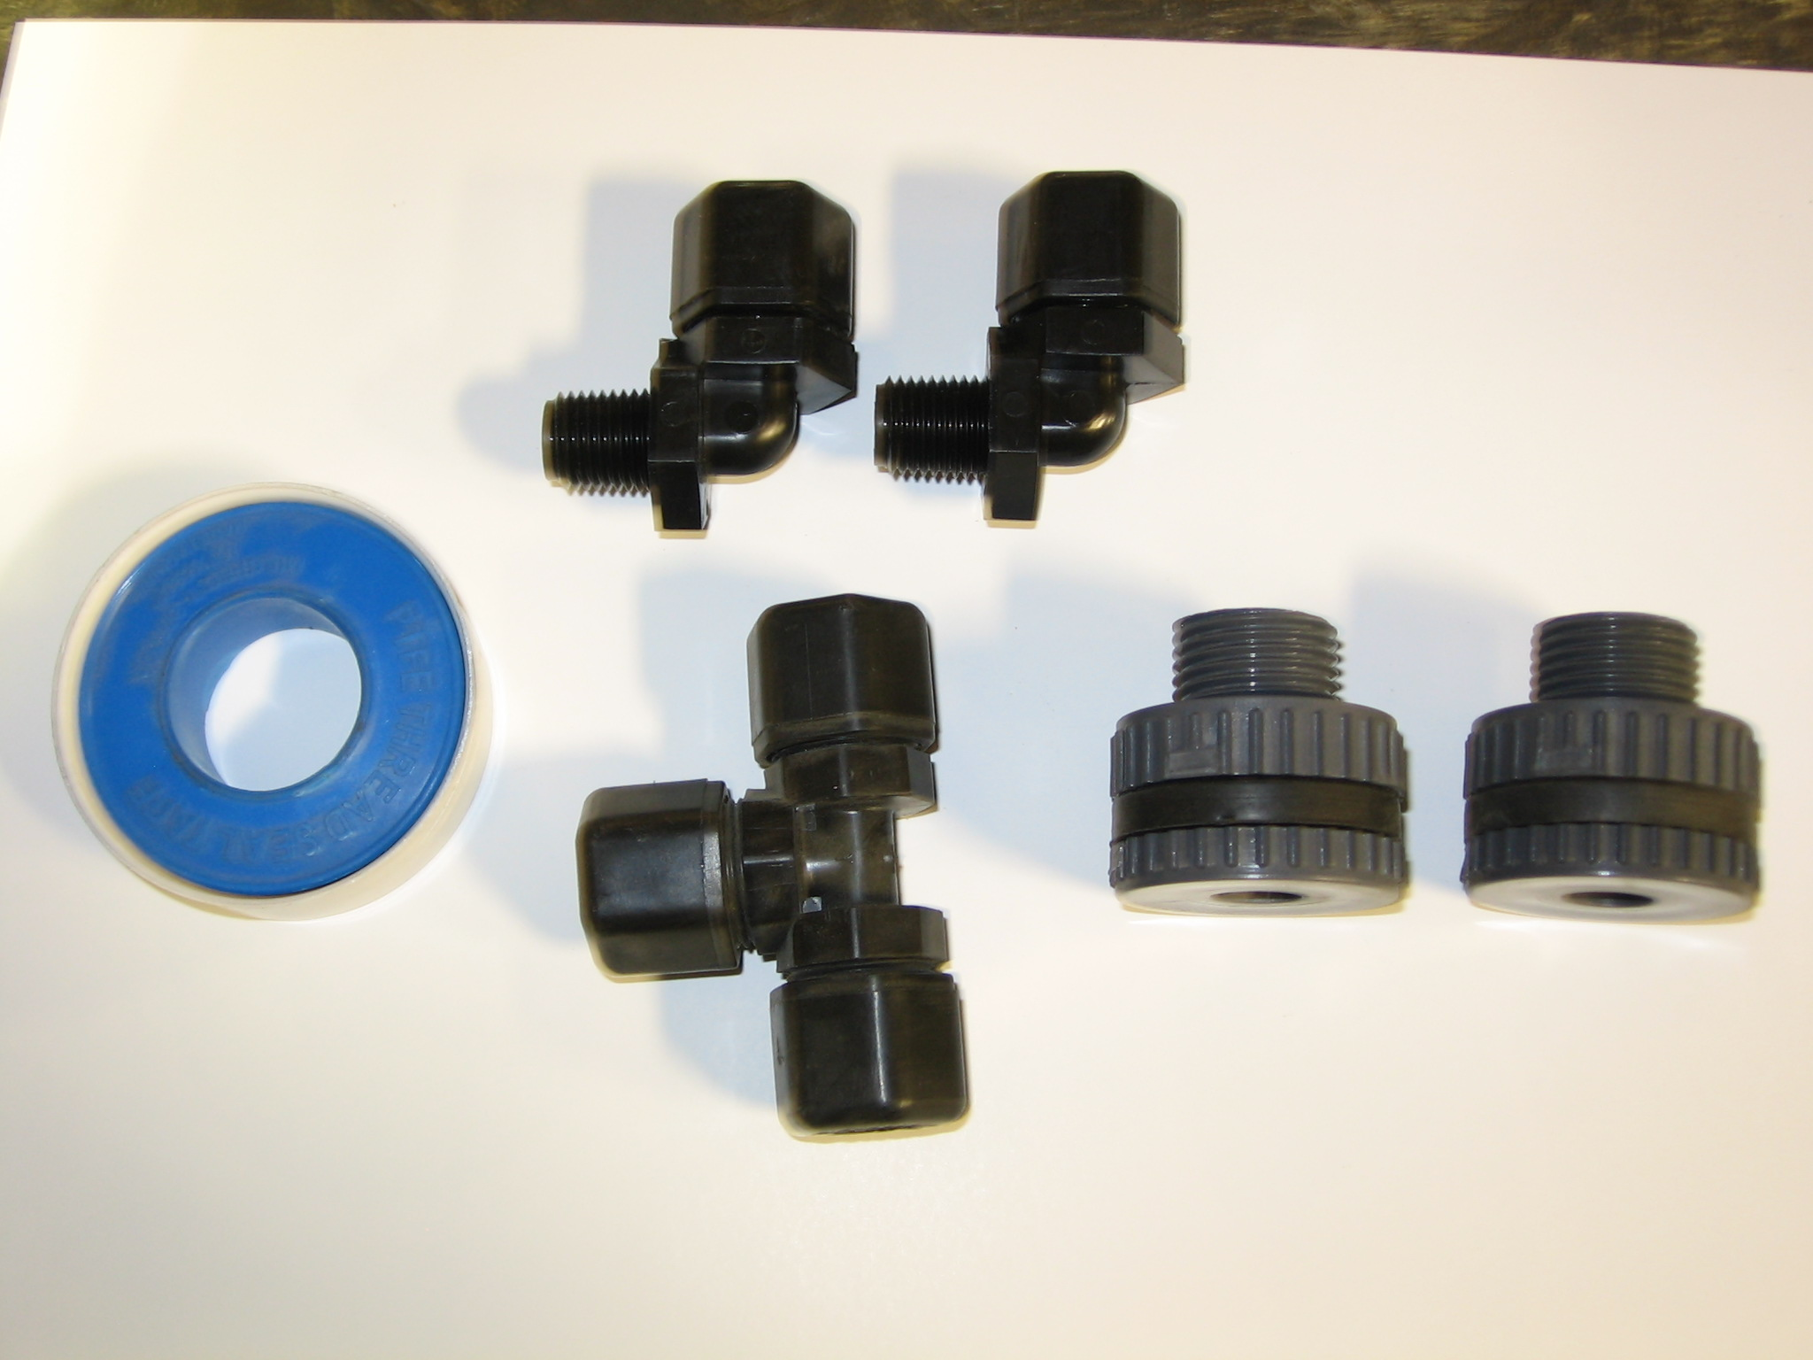 | 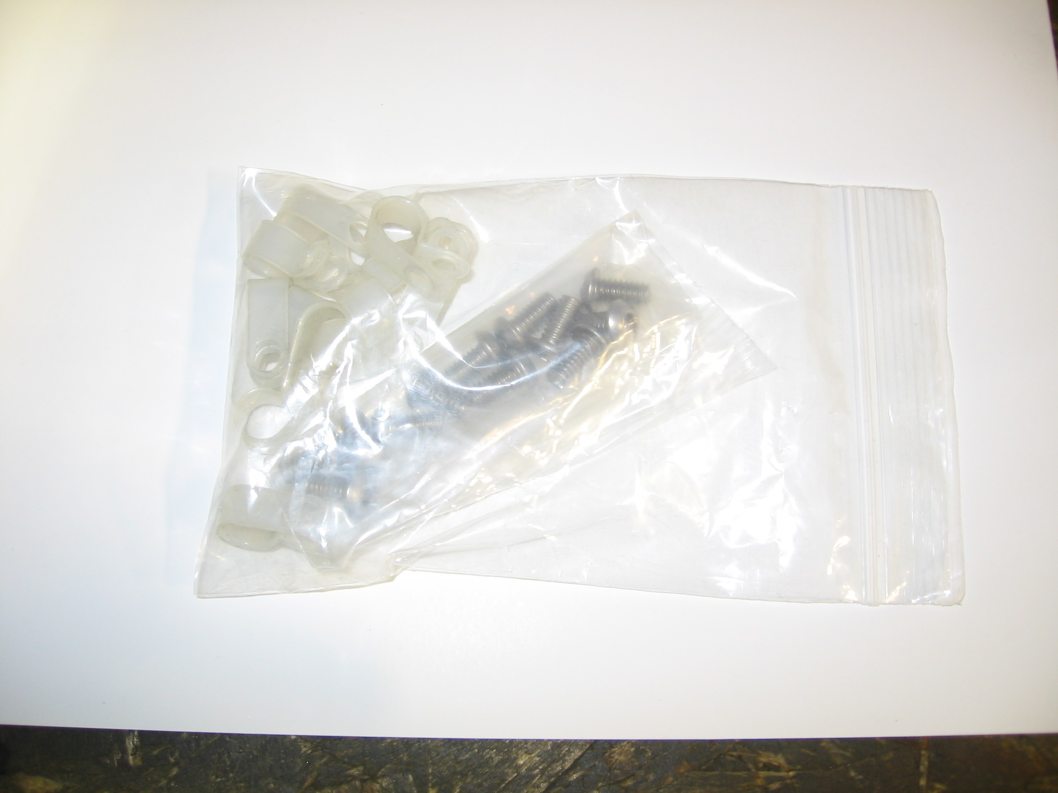
SPRAYER FITTINGS | HOSE HARDWARE

Installation Overview
The following tools are required to complete assembly and installation:
3/4” Wrench and socket
5/8” Wrench
9/16” Wrench and socket
1/2” Wrench and socket
7/32” Hex key
3/16” Hex key
Masonry drill
1/2” Masonry bit
9/16” Masonry bit
3/4” Drill bit
High strength epoxy (Red Head G5 or similar)
Framing square or tape measure

Assembly of your new slide will require a minimum three to four people and should be completed as close to the final installation site as possible.
Note: Assembly of 8’8” slide requires the use of a forklift or other lifting equipment for installation of the staircase.
Note: Once assembled, the slide is very heavy and difficult to maneuver. Slide should be assembled as close to the intended final location as possible.
Spectrum provides the following installation location recommendations:
- The end of the slide flumes should overhang the deck by at least 3 inches.
- The slide landing area shall extend at least 3 1/2’ feet to both sides of the centerline of the slide exit flume.
- The slide landing area should extend at least 25’ from the end of the slide exit section and should maintain a depth of at least 3’ extending 12’ from the end of the slide.
- The slide landing area should not interfere with any other diving or slide landing areas and should be separated from the rest of the pool with a floating buoy line or similar method.
- Note: The slide platform and flume supports must be bonded in accordance with the NEC and any applicable state and local codes. Bonding connections should be achieved using approved and listed methods.
Note: These recommendations may be superseded by state and local codes. It is the responsibility of the customer/installer to ensure that the slide is installed in a compliant manner.

Assembly Instruction
The slide is packaged partially assembled. Attach the stair frame end and the flume frame end to the legs using the 1/2” x 4” hardware. Be sure to locate the leg with the large hole at the bottom (for the sprayer hose) in the corner where it’s most convenient to attach the garden hose. The platform can be raised to the standing position at the desired slide location. Bolt the flume frame sides to the ends using the 1/2” x 4 1/2” hardware. Do not tighten the hardware until the center brace is installed and the platform is squared.
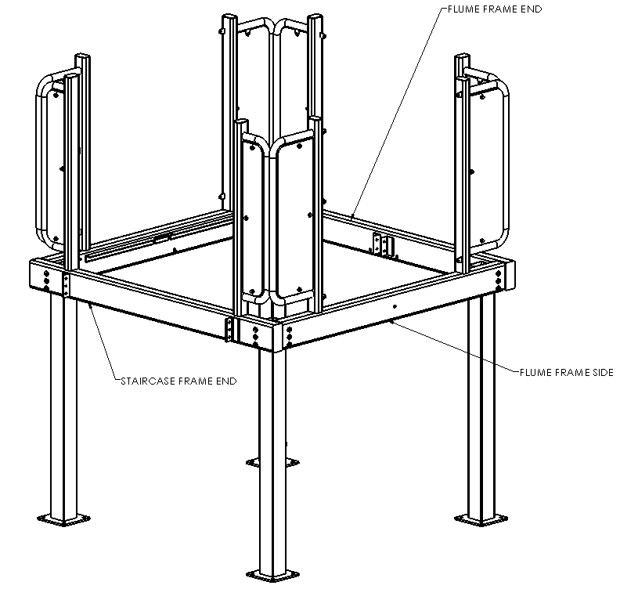
Install the center brace using the 1/2” x 3 1/2” hardware. The flanges on the center brace should be facing upward and will be used to secure the decking panels at a later time. The railings can be connected using the 5/16” x 2” hardware in the four (4) hole locations, one at the top corner of each railing. All polycarbonate panels are positioned on the mounting tabs with the panel on the outer side of the tab. Ensure flume and stair entrance locations are correctly oriented. Ensure the platform frame is square with the use of a framing square or by measuring the corner to corner distances. All of the frame hardware can now be tightened.

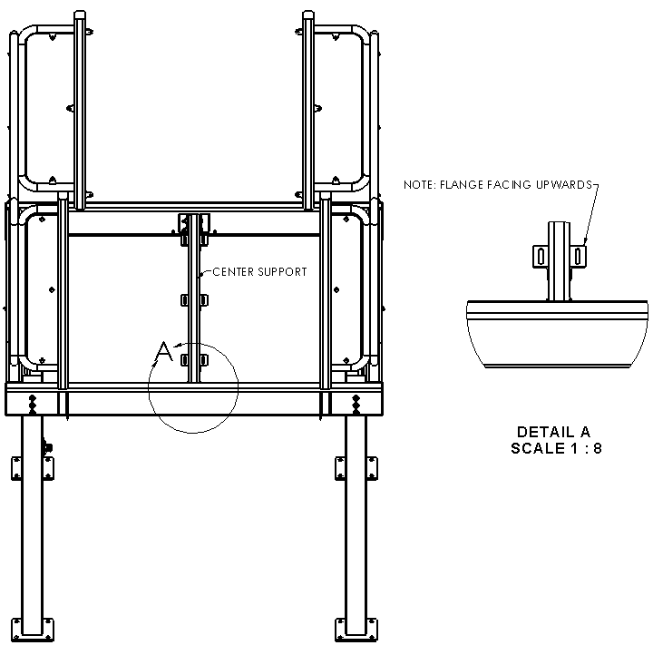
At this time the stairs can be attached to the frame using the 1/2” x 1” hardware. The decking can also be installed at this point. The decking is attached using the included clips and 5/16” hardware as shown below.
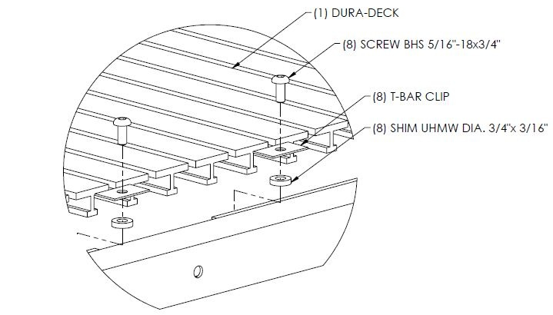
You can now install the stair railings. Keep in mind that the polycarbonate panels should be positioned on the outside of the stairs. The panels must be removed from the top potion to allow bolting to the mounting holes in the platform post using the included 5/16” x 1” hardware.
Note: Leave protective covering on all polycarbonate panels until installation is complete to avoid damage to the panels.

To prepare the slide flumes for assembly, apply the flume gasket material as shown below. Gasket material should be applied to the flange without a lip on each section. Overlap the ends of the gasket material by at least 1/2” to ensure a complete sealing.
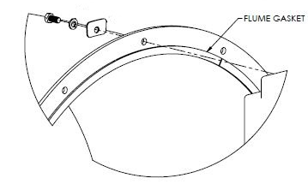
Note: When installing flume sections it is easiest to bolt the sections together by placing a bolt in the top hole then the bottom hole followed by the left and right holes making a + pattern.
Note: Flume assembly works best if one flume section is completely attached before moving on to the next section.
Note: If necessary flume hardware holes can be enlarged up to 9/16” in one side of the joint to achieve secure attachment.
All flume configurations follow. It is best to begin assembly at the top of the flume and work down.

OPTIONAL STRAIGHT FLUME ASSEMBLY
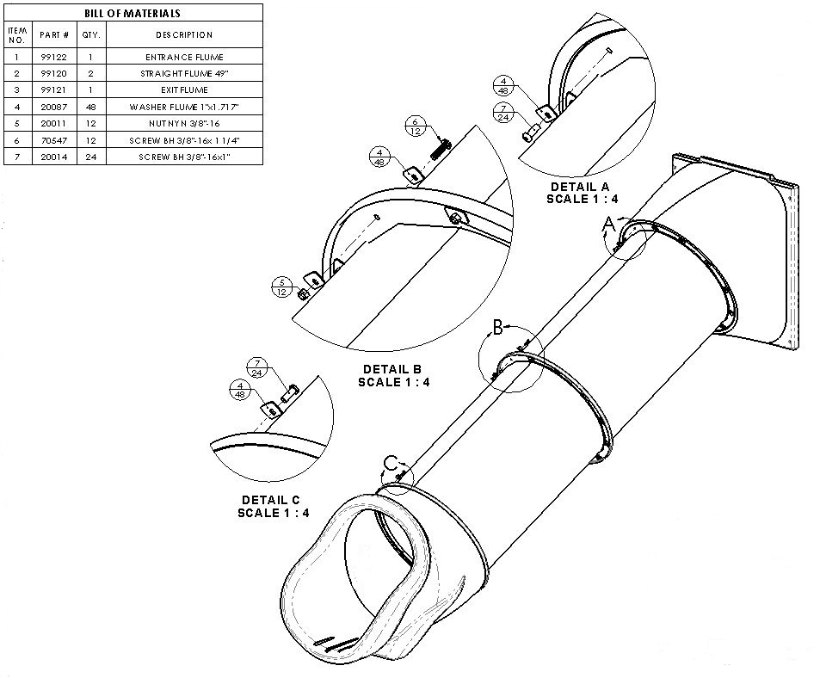
The 30° flume entrance section can be installed using the 3/8” x 2 1/2” hardware. After installing the entrance section the first straight section should be installed. The flume section should be installed the seam aligned with the topmost hole on the entrance panel, using 5/16” x 1 1/4” hardware and flume washers. Continue by attaching the second straight flume section and exit as indicated.

OPTIONAL ANGLED FLUME ASSEMBLY
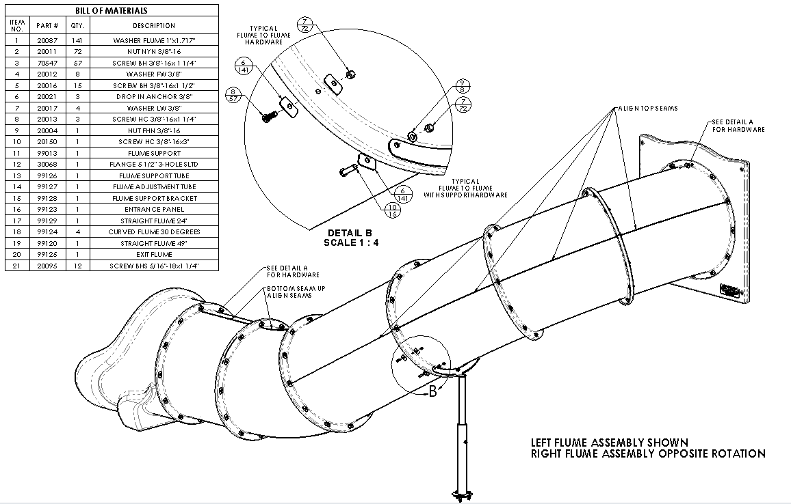
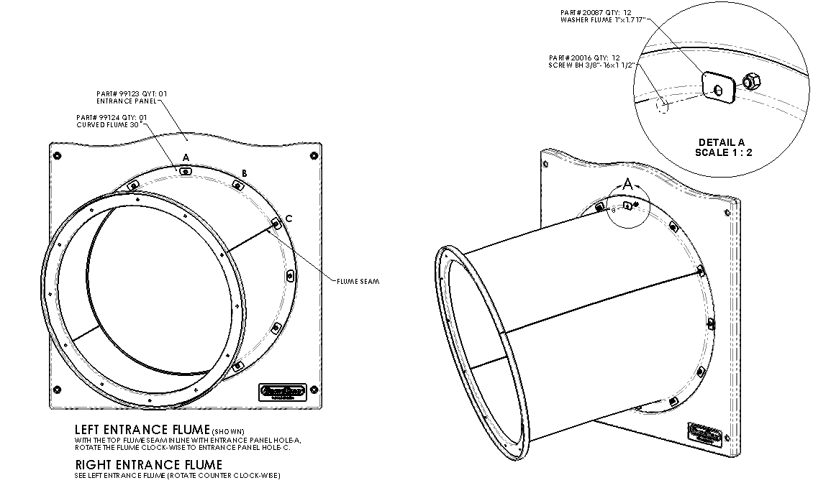
To begin installation of the flumes, attach the flume entrance panel using the included 3/8” x 2 1/2” hardware. Once this is completed the remaining flumes can be installed as indicated.

OPTIONAL 8FT FLUME ASSEMBLY
Assemble flume as indicated by following instructions.
Note: It may be easiest to install the first straight section prior to installing the flume entrance.
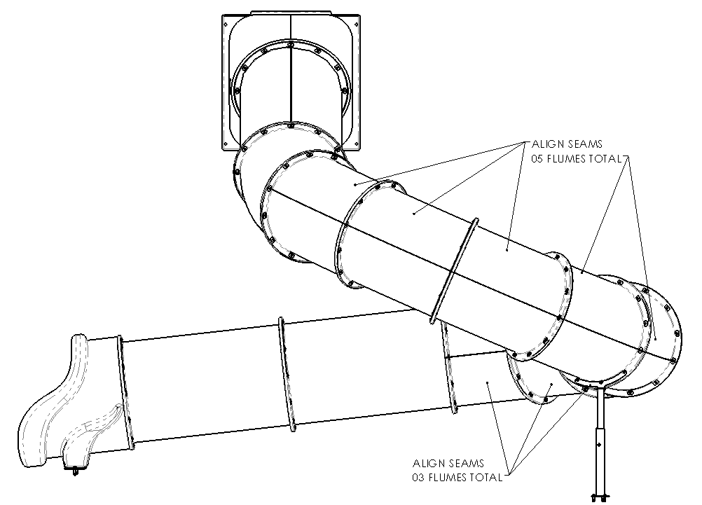
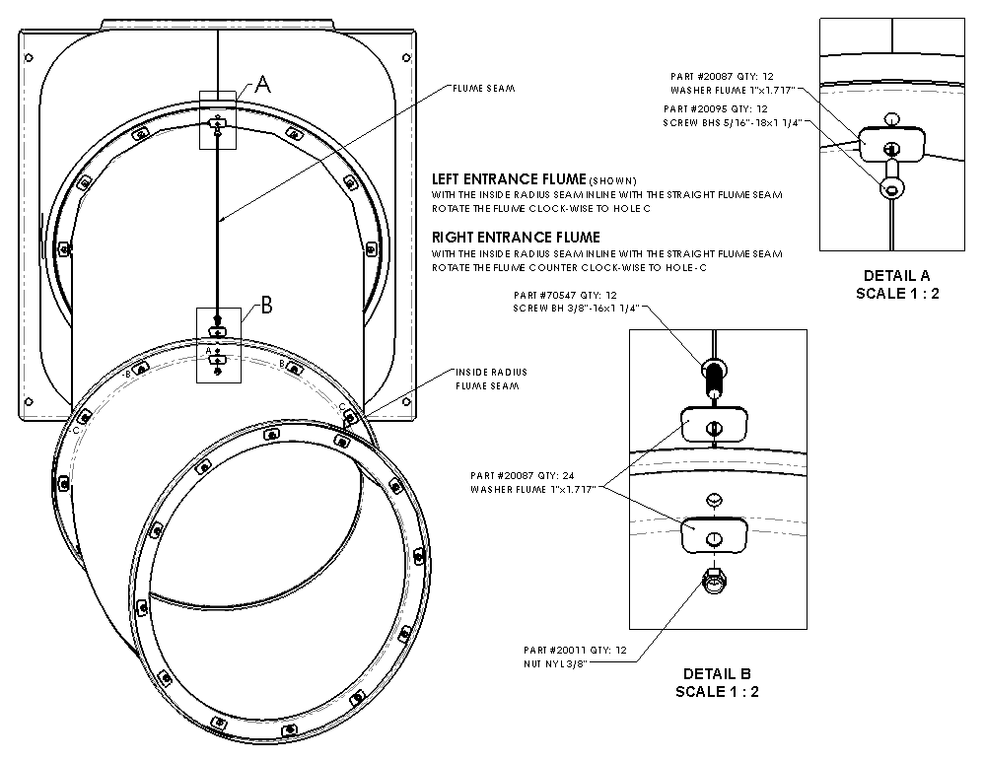
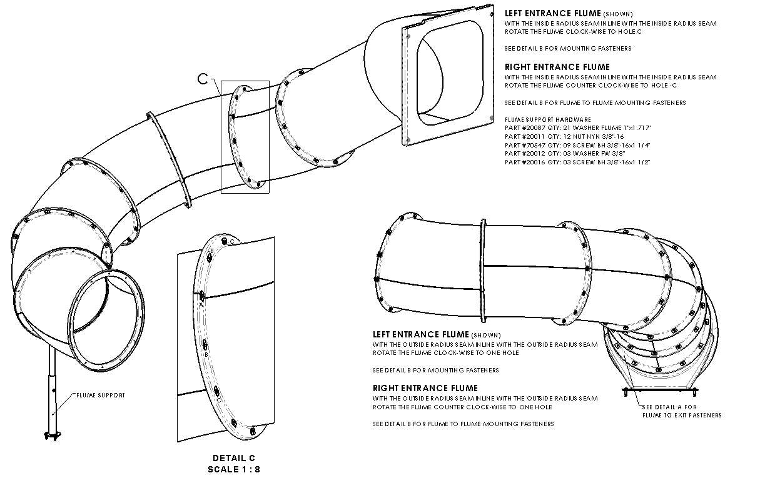
Sprayer Attachment
Once the flume assembly is completed, the sprayer hardware can be installed. To begin sprayer installation, drill two 3/4” holes in the first flume section of each slide aligned with the second bolt hole down from the topmost position.
Note: When drilling sprayer holes for the side flumes, ensure that the holes are at least 12” from the entrance panel when measured perpendicularly.
Once the holes are drilled, install the sprayer nozzles into the flume using the elbows.
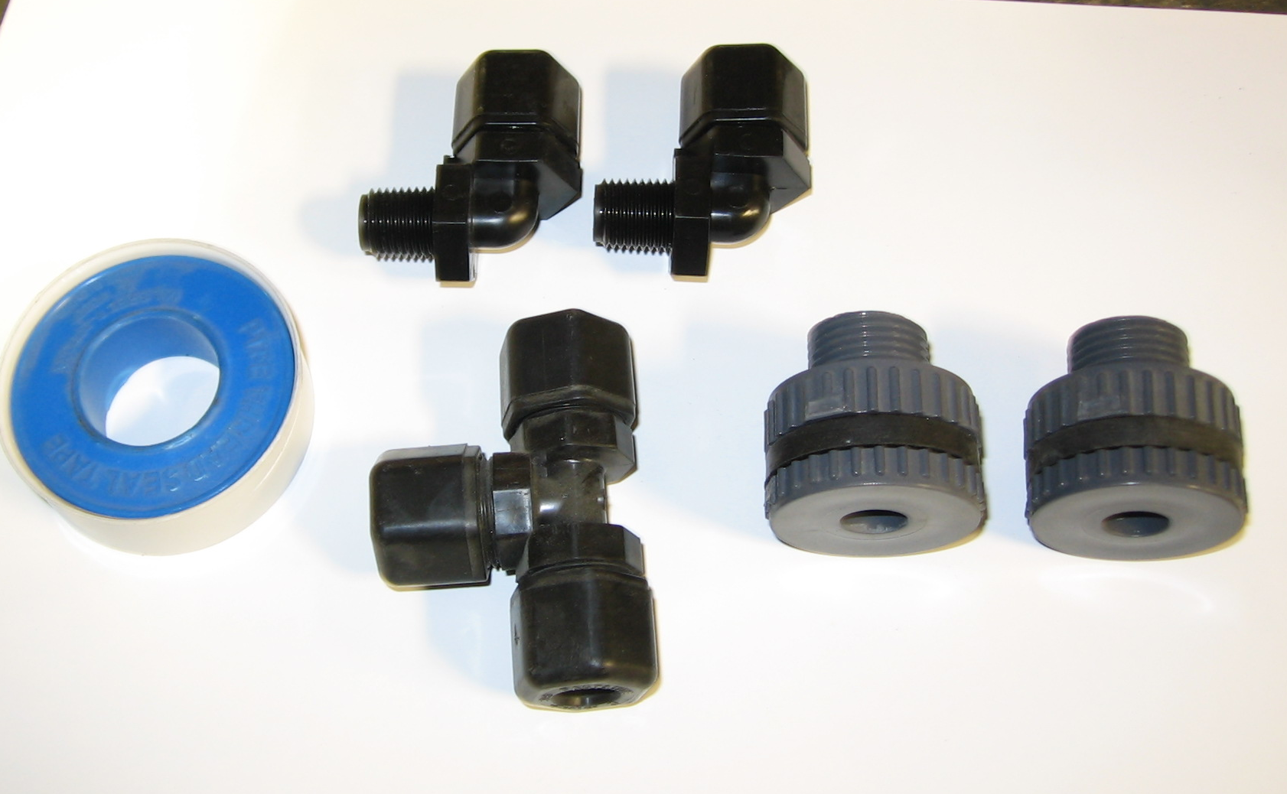
Nozzles & Elbows

Clips & bolts

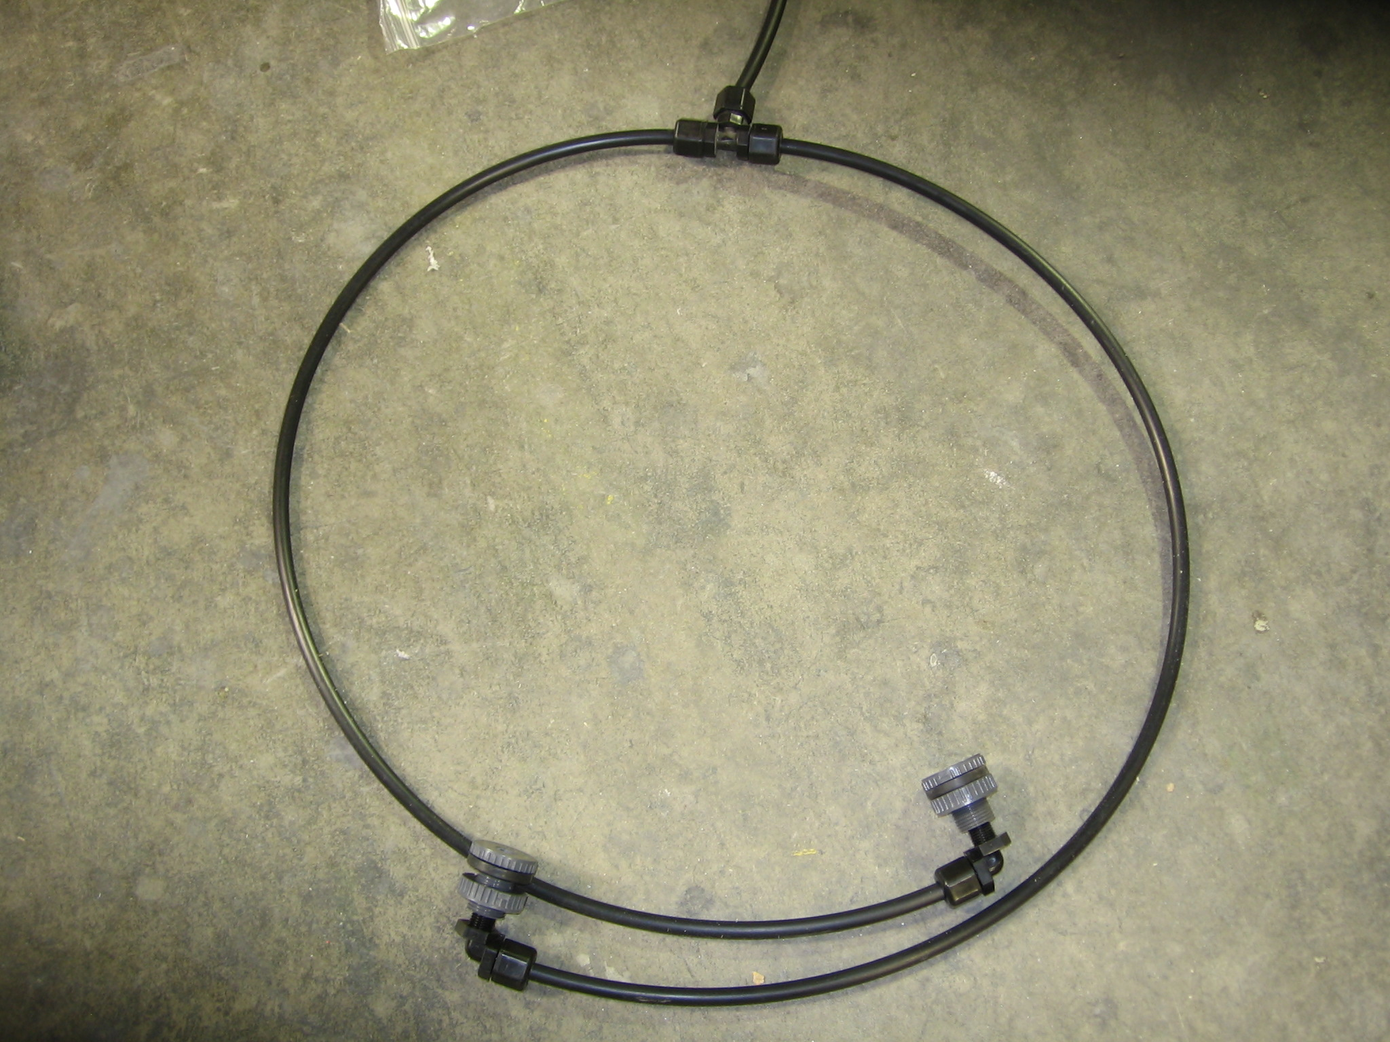
Cut two hose pieces to length for wrapping under flume and connecting with the T.
Attach clips to the platform (3 on back side of each side frame and one on front side of final side frame under slide).
Run the hose from the T around the underside of the platform and down the leg (through pre-drilled hole) and out the bottom drilled and tapped hole. Connect to the hose fitting at the bottom.
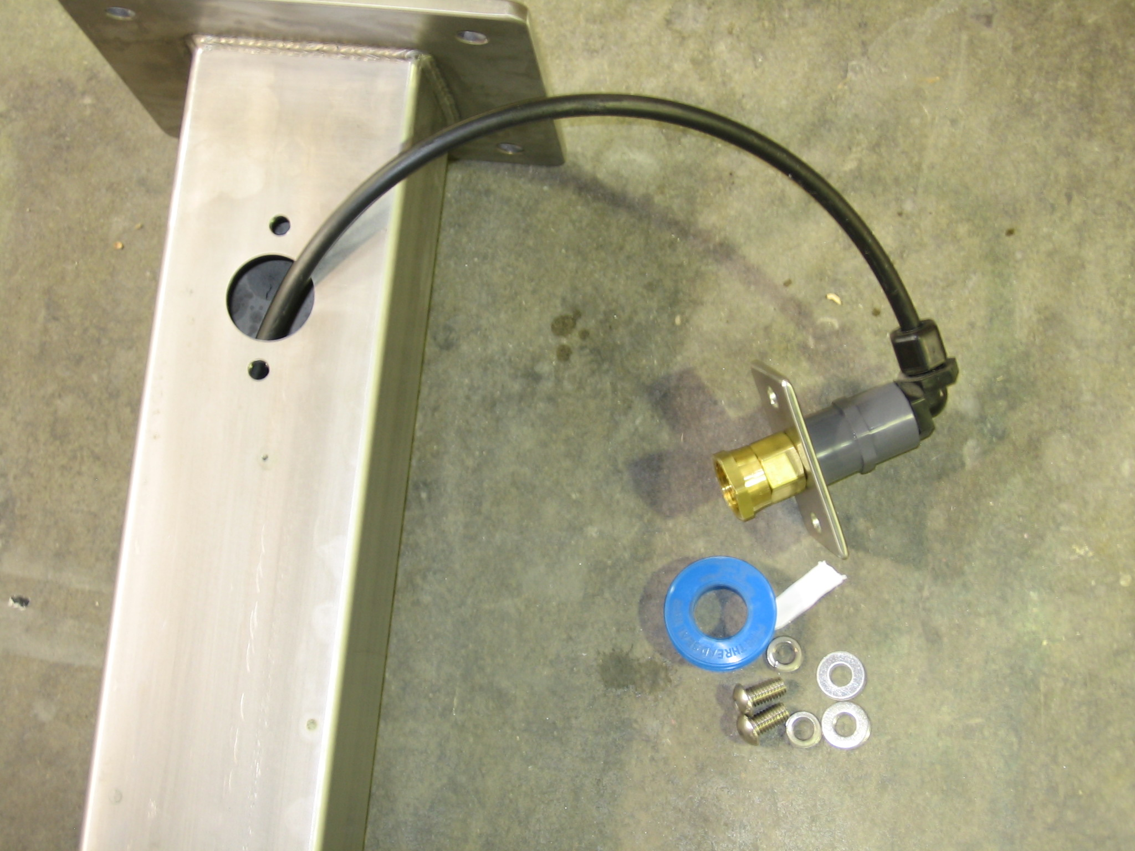
Ensure that all hoses are connected before turning on the water supply for the first time.

At this time the platform can be secured to the deck using the provided 1/2” anchors. Anchors should be secured using ITW Red Head adhesive anchoring compound G5 or comparable product.
Note: Slide structure should be level. This can be accomplished using the included shims.
- Drill 9/16" holes for 1/2" diameter threaded rod. Clean the hole from the bottom with forced air. Complete preparation of the hole with brush and repeat cleaning with forced air. Ensure that hole is completely free of debris before continuing.
- When starting new cartridge or new nozzle, dispense and discard enough adhesive until uniform color is achieved. Insert the nozzle into the bottom of the hole and fill to 1/2 the hole depth.
- Insert rod slowly by hand into the bottom of the hole with a slow twisting motion. This insures adhesive fills voids and crevices and uniformly coats the anchor rod. After the manufacturer suggested cure time is met, install and tighten fixture into place.
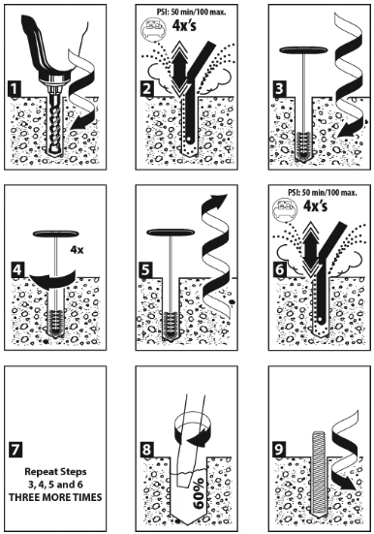
- Check the position of the exit flume support in relation to the pool and the pillars of the main platform, move to specified dimensions. Then attach flume supports in place with drop in anchors by drilling a 1/2" hole roughly 1-5/8" deep. Once the hole is drilled and cleared of debris, insert the drop in anchors and set in place using the included tool. Secure flume support with included 3/8” hardware.
Note: Always follow manufacturer recommendations for anchoring adhesive and drop-in anchors.

Operator’s Guide

Care and Maintenance
The proper care and maintenance of your slide is essential and is your responsibility. Inspect your slide and its components on a regular basis. These inspections should include, but are not limited to, the following:

• Check panels to make sure they are in good condition and show no signs of stress.
• Check each panel’s adherence to the frame. Tighten only when they are loose. Do not over tighten!
• Check for sharp points and edges.
• Remove or repair any damaged panel areas.
• Clean panels with mild soap or Windex.
• Remove any discoloration to the stainless steel fame with a 3M scratch pad. Wipe clean with a sponge dampened with Spectra Clean. Repeat these steps several times to passivate the stainless steel. Spectra Clean kits are available from Spectrum Aquatics (Part Number 47906), call 800.791.8056. Do not spray with high-pressure water; only clean with non-chlorinated fresh water.

Pool Slide Rules:
- No sliding without lifeguard/slide attendant on duty
- Wait until slide attendant tells you “GO”
- Feet first sliding only
- One slider at a time – no trains or doubles
- Exit the plunge area immediately
- No dangling jewelry or accessories

Rider Requirements:
- Sliders must be at least 48-inches tall
- Non-swimmers are required to wear life jackets
- Slider cannot hold toys or other items

Please contact your local distributor or Spectrum Customer Service to order parts 406.532.6321

